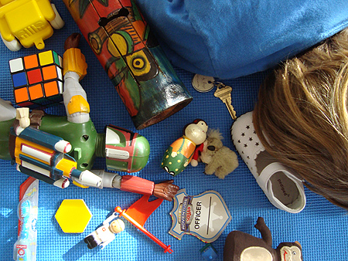
ISPY! Huck Finn!
Create a page for our class ISPY book. We will bind our book and keep it in the class room. Be creative and have fun!!
You may with alone or with a partner to create the page assigned to you. You can use virtually any means to create your page – hand drawing, computer cut and paste, literal cut and paste, photograph. You page must meet the following requirements:
- Address the scene from the book assigned to you
- Fill a full page (8 ½ X 11)
- Contain 5-7 items important to the book
- Contain your name
- Clearly represent the scene in question
- Be neat and show effort!
- List the items to be searched for somewhere on the page.
- Explain the significance of each item in paragraph form. (See example below.)
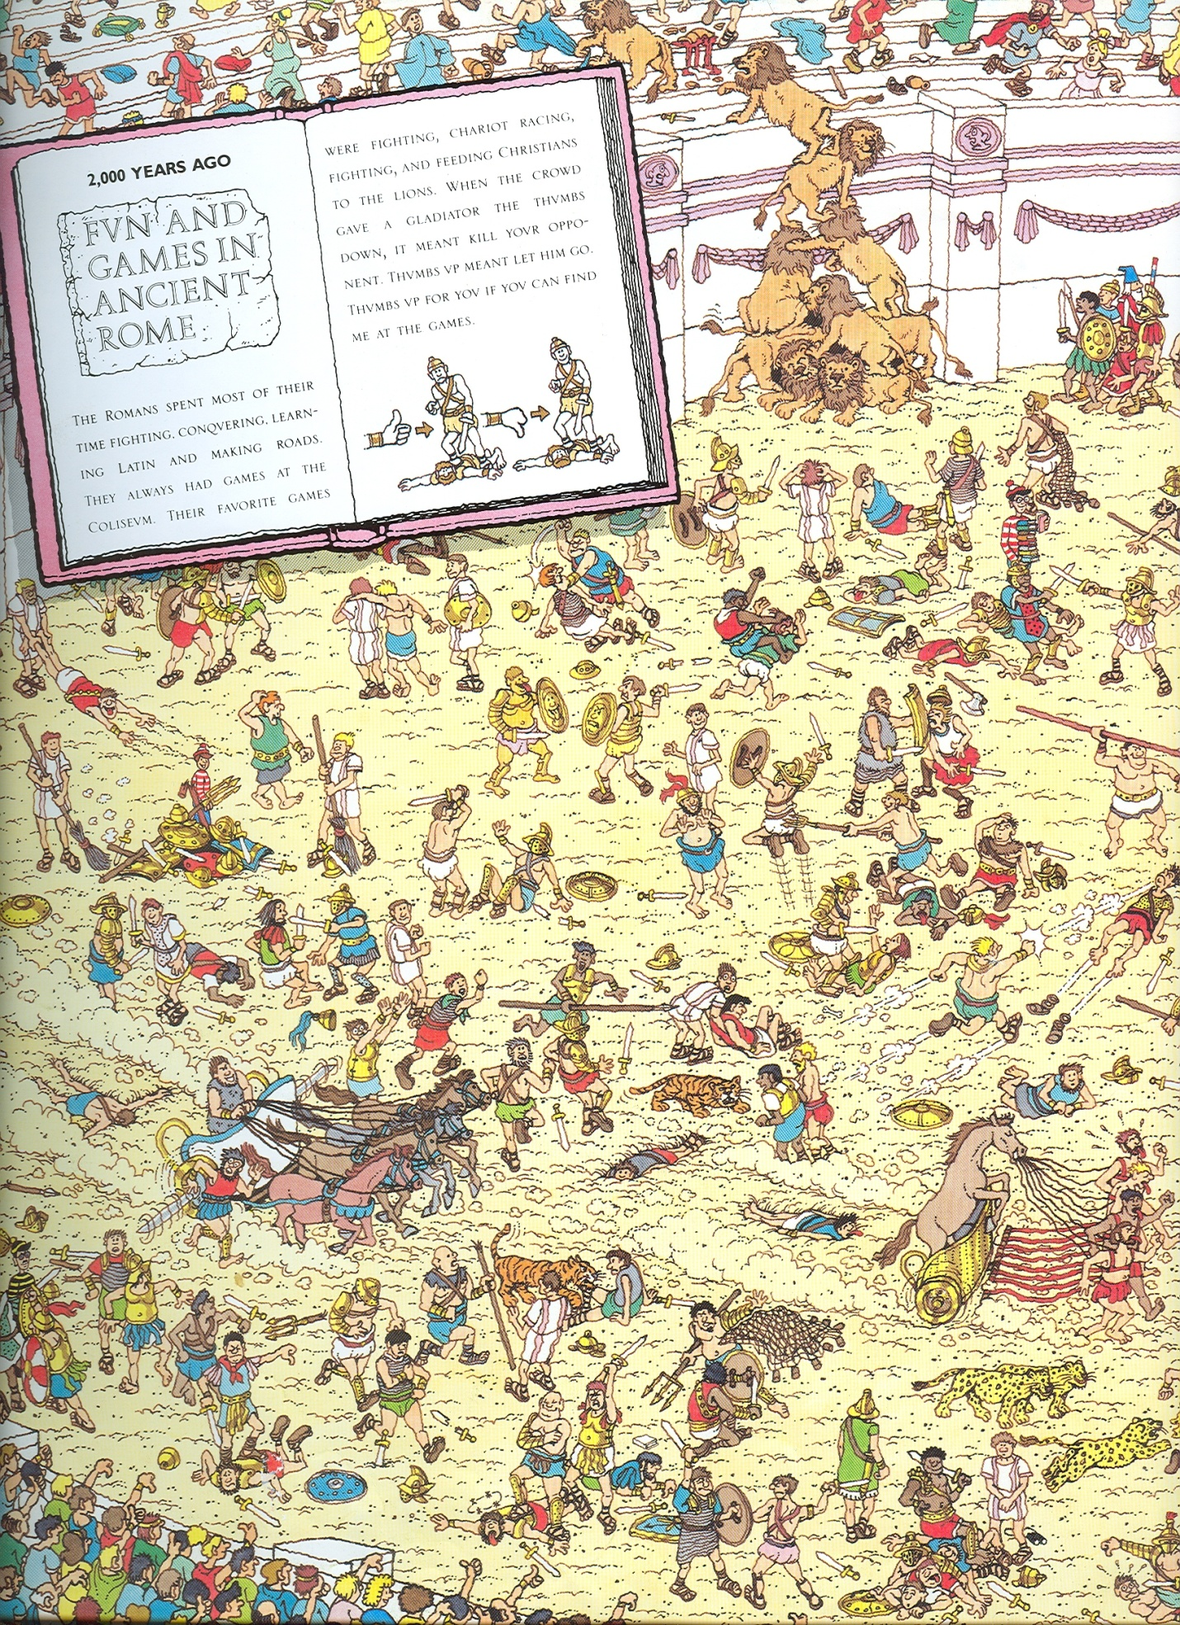
- Be school appropriate.
 | Points Earned | Points Possible
Content |  | 5
Size/neatness |  | 5
Quality of items |  | 5
Items list |  | 5
Paragraph |  | 10
Creativity (extra credit!) |  | 0
TOTAL |  | 30
ISPY! Huck Finn!
Create a page for our class ISPY book. We will bind our book and keep it in the class room. Be creative and have fun!!
Choose one of the following scenes/events for your page and sign your name beside it. No repeats allowed.
________________________ The Widow’s House
________________________ Pap’s Cabin
________________________
________________________ Jackson’s Island
________________________ The Wilkes’
________________________ The “House of Death”
________________________ The Raft
________________________ The Walter Scott (shipwreck)
________________________ The Shepherdson’s
________________________ Huck’s girly disguise
________________________ The Duke and King’s cons
________________________ The Phelps’ Place
________________________ Jim’s “prison”
________________________

