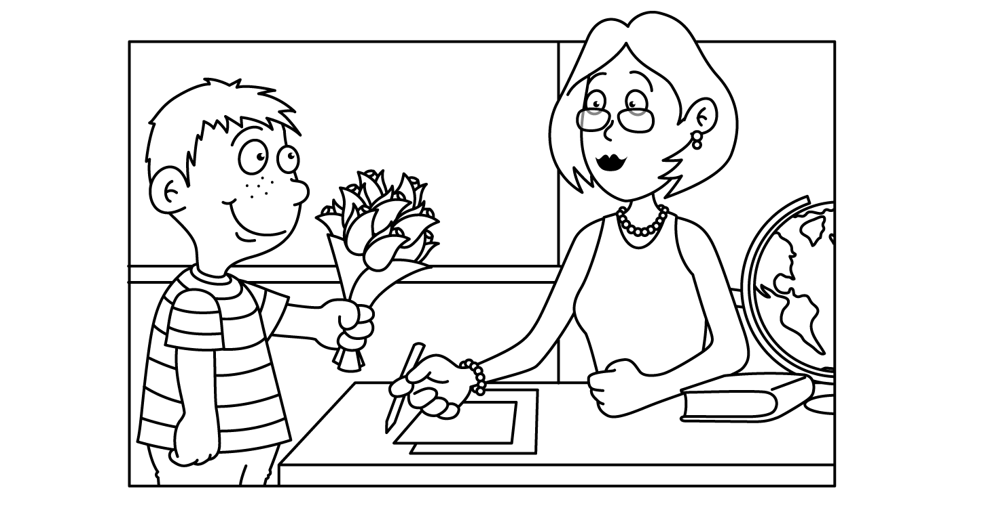

English 10 MAY 2013
Sunday | Monday | Tuesday | Wednesday | Thursday | Friday | Saturday
 |  |  |  | 9  CL 270  Practice test | 10  Pay it Forward and silent reading | 11
12 | 13  ECA review  & Silent reading | 14  3rd and 5th CL 237  ECA test  7th Book wkst | 15  3rd and 5th CL 237  ECA test  7th Book wkst  Library books due! | 16  3rd and 5th Book wkst  7th CL 237 ECA text | 17  3rd and 5th Book wkst  7th CL 237 ECA text | 18
19 | 20  CL 237 Book II ECA test  For all. | 21  Review for finals  Book project work | 22  Review for finals  Book project work | 23  Review for finals  Book project work | 24  Finals  Book Projects due | 25
26 | 27  MEMORIAL DAY – No School! | 28  Finals  End Pay it Forward | 29  Finals & last day  End Pay it Forward | 30

